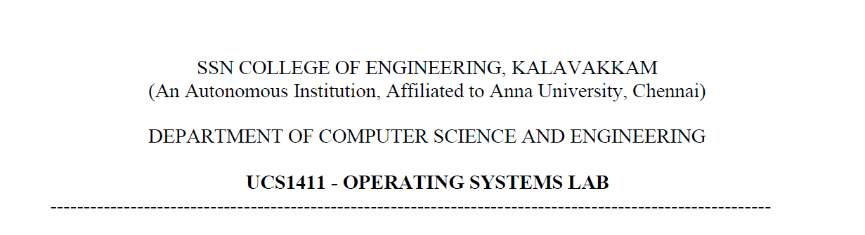

**LAB EXERCISE 4**

**Implementation of CPU Scheduling Policies**

**Submission Date:07-04-2022**

Name: Jayannthan P T

Dept: CSE ‘A’

Roll No.: 205001049

Develop a menu driven C program to implement the CPU Scheduling Algorithms

1. Priority (Non-Preemptive and Preemptive)
2. Round Robin

**Algorithm for Priority** **Preemptive:**

1. Get total no of process from the user.
2. Get process id, arrival time, burst time, priority for all process.
3. Take a temporary burst time(rem_time) to have a value of remining burst time of all the process
4. Have count of completed process, current time.
5. Loop until completed less than total no of process
   1. Compare priority of current running job and new entering job at that current time
   2. If priority is greater then stop the current processor and update rem_time and begin the new process
   3. Else continue until the process ends
   4. While the process ends set completion time as current time, waiting time as completion time minus sum of arrival time and burst time, turnaround time as sum of waiting time and burst time, update total turnaround time and total waiting time
6. Calculate average waiting time by dividing total waiting time by total no of process
7. Calculate average turnaround time by dividing total turnaround time by total no of process
8. Print process table
9. Print Gantt Chart

**Algorithm for Round Robin:**

1. Get total no of process, time quantum from the user.
2. Get process id, arrival time, burst time for all process.
3. Take a temporary burst time(rem_time) to have a value of remining burst time of all the process
4. Sort the process based on arrival time.
5. Have count of completed process, current time.
6. Loop until all process ends
   1. If rem_time is less than or equal to quantum then current time is sum of current time and burst time of the process and set turnaround time as current time minus arrival time, waiting time as current time minus sum of arrival time and burst time, update total turnaround time and total waiting time
   2. Else update rem_time as rem_time minus quantum and current time is sum of current time and quantum
7. Calculate average waiting time by dividing total waiting time by total no of process
8. Calculate average turnaround time by dividing total turnaround time by total no of process
9. Print process table
10. Print Gantt Chart

**Code:**

*/*Develop a menu driven C program to implement the CPU Scheduling Algorithms - Priority*

*(Non-Preemptive and Preemptive) and Round Robin*

*Algorithm: 1. Read the following a. Number of p b. Process IDs c. Arrival time for each process d. Burst Time for each process 2. Design a menu with FCFSand SJFoptions 3. Upon selection of menu option apply the corresponding algorithm. 4. Compute the Turnaround Time, Average waiting Time for each of the algorithm. 5. Tabularize the results. 6. Display the Gantt Chart.*/*

#include <stdio.h>

#include <stdlib.h>

#include <fcntl.h>

#include <string.h>

typedef **struct** process

{

**char** pid[3];

**int** arrival, burst,teempburst, turnaround, waiting, completion, priority;

} process;

**void** print_gantt_chart(process p**[]**, **int** n)

{

    printf("\n\nGantt-Chart\n");

**int** i, j;

    printf(" ");

    for (i = 0; i < n; i++)

    {

        for (j = 0; j < p[i].burst; j++)

            printf("--");

        printf(" ");

    }

    printf("\n|");

    for (i = 0; i < n; i++)

    {

        for (j = 0; j < p[i].burst - 1; j++)

            printf(" ");

        printf("P%s", p[i].pid);

        for (j = 0; j < p[i].burst - 1; j++)

            printf(" ");

        printf("|");

    }

    printf("\n ");

    for (i = 0; i < n; i++)

    {

        for (j = 0; j < p[i].burst; j++)

            printf("--");

        printf(" ");

    }

    printf("\n");

    printf("0");

    for (i = 0; i < n; i++)

    {

        for (j = 0; j < p[i].burst; j++)

            printf("  ");

        if (p[i].turnaround > 9)

            printf("\b");

        printf("%d", p[i].turnaround);

    }

    printf("\n");

}

**int** main()

{

**int** no_of_process;

**int** totalwaitingtime = 0, totalturnaround = 0;

**int** pos;

**char** ch = 'y';

    process p[100];

    while (ch == 'y' || ch == 'Y')

    {

**int** choice;

        printf("\nMenu\n\t1.Priority-Non Preemptive\n\t2.Priority-Preemptive\n\t3.Round Robin\n\t4.Exit\n\t\nEnter Choice:");

        scanf(" %d", &choice);

        switch (choice)

        {

        case 1:

        {

            printf("\nPriority-Non Preemptive\n");

**int** no_of_process;

            printf("\nNumber of p :");

            scanf(" %d", &no_of_process);

            for (**int** i = 0; i < no_of_process; i++)

            {

                printf("\n\nProcess %d\n", i + 1);

                printf("Process ID: ");

                scanf(" %s", p[i].pid);

                printf("Burst Time :");

                scanf(" %d", &p[i].burst);

                printf("Priority :");

                scanf(" %d", &p[i].priority);

            }

            process temppro;

            for (**int** i = 0; i < no_of_process; i++)

            {

                pos = i;

                for (**int** j = i + 1; j < no_of_process; j++)

                {

                    if (p[j].priority < p[pos].priority)

                        pos = j;

                }

                temppro = p[i];

                p[i] = p[pos];

                p[pos] = temppro;

            }

            totalwaitingtime = 0, totalturnaround = 0;

            p[0].waiting = 0;

            p[0].turnaround = p[0].burst;

            totalturnaround += p[0].turnaround;

            for (**int** i = 1; i < no_of_process; i++)

            {

                if (p[i - 1].waiting + p[i - 1].burst - p[i].arrival > 0)

                {

                    p[i].waiting = p[i - 1].waiting + p[i - 1].burst - p[i].arrival;

                }

                else

                {

                    p[i].waiting = 0;

                }

                totalwaitingtime += p[i].waiting;

                p[i].turnaround = p[i].burst + p[i].waiting;

                totalturnaround += p[i].turnaround;

            }

            printf("\nP_ID\tBurst Time\tPriority\tWaiting Time\t\tTurnaround Time\n");

            for (**int** i = 0; i < no_of_process; i++)

            {

                printf("%s\t\t%d\t\t%d\t\t%d\t\t\t%d\n", p[i].pid, p[i].burst, p[i].priority, p[i].waiting, p[i].turnaround);

            }

**float** avgwaiting = (**float**)(totalwaitingtime / no_of_process);

**float** avgturnaround = (**float**)(totalturnaround / no_of_process);

            printf("\n\t\tAVERAGE \tWaitingTime =%.2f\t TurnaroundTime =%.2f\n", totalwaitingtime / no_of_process, totalturnaround / no_of_process);

            print_gantt_chart(p, no_of_process);

            break;

        }

        case 2:

        {

            printf("\nPriority-Preemptive\n");

**int** no_of_process;

            printf("\nNumber of process :");

            scanf(" %d", &no_of_process);

**int** tempburst[100];

            for (**int** i = 0; i < no_of_process; i++)

            {

                printf("\n\nProcess %d\n", i + 1);

                printf("Process ID: ");

                scanf(" %s", p[i].pid);

                printf("Arrival Time :");

                scanf(" %d", &p[i].arrival);

                printf("Burst Time :");

                scanf(" %d", &p[i].burst);

                printf("Priority :");

                scanf(" %d", &p[i].priority);

                tempburst[i] = p[i].burst;

                p[i].teempburst = p[i].burst;

            }

**int** rem_time[no_of_process];

            for (**int** i = 0; i < no_of_process; i++)

                rem_time[i] = p[i].burst;

            process tempro[100];

**int** tempcount = 0;

**int** completed = 0;

**int** cur_time = 0;

            while (completed < no_of_process)

            {

**int** idx = -1;

                for (**int** i = 0; i < no_of_process; i++)

                {

                    if (p[i].arrival <= cur_time && rem_time[i] > 0 && (idx == -1 || p[i].priority < p[idx].priority))

                        idx = i;

                }

                cur_time++;

                if (tempcount != 0 && strcmp(tempro[tempcount-1].pid,p[idx].pid)) tempcount--;

                else

                {

                    tempro[tempcount] = p[idx];

                }

                strcpy(tempro[tempcount].pid,p[idx].pid);

                tempro[tempcount].burst++;

                tempro[tempcount].turnaround = cur_time;

                tempcount++;

                rem_time[idx]--;

                if(rem_time[idx]==0)

                {

                    completed++;

                    p[idx].completion = cur_time;

                    p[idx].waiting = p[idx].completion - p[idx].arrival - p[idx].burst;

                    p[idx].turnaround = p[idx].burst + p[idx].waiting;

                }

            }

            for (**int** i = 0; i < no_of_process; i++)

            {

                totalwaitingtime+=p[i].waiting;

                totalturnaround+=p[i].turnaround;

            }

            printf("\nP_ID\tArrival Time\tBurst Time\tPriority\tWaiting Time\t\tTurnaround Time\n");

            for (**int** i = 0; i < no_of_process; i++)

            {

                printf("%s\t\t%d\t\t%d\t\t%d\t\t%d\t\t\t%d\n", p[i].pid, p[i].arrival, p[i].burst, p[i].priority, p[i].waiting, p[i].turnaround);

            }

**float** avgwaiting = (**float**)(totalwaitingtime / no_of_process);

**float** avgturnaround = (**float**)(totalturnaround / no_of_process);

            printf("\n\t\tAVERAGE \tWaitingTime =%.2f\t TurnaroundTime =%.2f\n", avgwaiting, avgturnaround);

            process temmptemppro[100];

**int** temptempcount=-1;

            for(**int** i=0;i<tempcount;i++)

            {

                if(strcmp(tempro[i+1].pid,tempro[i].pid)!=0)

                {

                    temmptemppro[++temptempcount]=tempro[i];

                }

            }

            print_gantt_chart(temmptemppro, temptempcount+1);

            print_gantt_chart(tempro, tempcount);

            break;

        }

        case 3:

        {

            printf("\nRound Robin\n");

**int** no_of_process;

**int** quantum;

            printf("\nNumber of p :");

            scanf(" %d", &no_of_process);

**int** temp_nop = no_of_process;

            process temppro[100];

**int** tempburst[100];

**int** count = 0;

**int** tempcount = -1;

            for (**int** i = 0; i < no_of_process; i++)

            {

                printf("\n\nProcess %d\n", i + 1);

                printf("Process ID: ");

                scanf(" %s", p[i].pid);

                printf("Arrival Time :");

                scanf(" %d", &p[i].arrival);

                printf("Burst Time :");

                scanf(" %d", &p[i].burst);

                tempburst[i] = p[i].burst;

            }

            process tempppro;

            for (**int** i = 0; i < no_of_process; i++)

            {

                pos = i;

                for (**int** j = i + 1; j < no_of_process; j++)

                {

                    if (p[j].arrival < p[pos].arrival)

                        pos = j;

                }

                tempppro = p[i];

                p[i] = p[pos];

                p[pos] = tempppro;

            }

            totalwaitingtime = 0, totalturnaround = 0;

            p[0].waiting = 0;

            printf("\nTime Quantum :");

            scanf(" %d", &quantum);

            for (**int** sum = 0, i = 0; temp_nop != 0;)

            {

                if (tempburst[i] <= quantum && tempburst[i] > 0)

                {

**int** temptempburst = tempburst[i];

                    sum = sum + tempburst[i];

                    tempburst[i] = 0;

                    count = 1;

                    tempcount++;

                    strcpy(temppro[tempcount].pid, p[i].pid);

                    temppro[tempcount].burst = temptempburst;

                    temppro[tempcount].arrival = p[i].arrival;

                    temppro[tempcount].turnaround = sum;

                }

                else if (tempburst[i] > 0)

                {

                    tempburst[i] = tempburst[i] - quantum;

                    sum = sum + quantum;

                    tempcount++;

                    strcpy(temppro[tempcount].pid, p[i].pid);

                    temppro[tempcount].burst = quantum;

                    temppro[tempcount].arrival = p[i].arrival;

                    temppro[tempcount].turnaround = sum;

                    temppro[tempcount].waiting = sum - p[i].arrival - quantum;

                }

                if (tempburst[i] == 0 && count == 1)

                {

                    temp_nop--;

                    p[i].turnaround = sum - p[i].arrival;

                    p[i].waiting = sum - p[i].arrival - p[i].burst;

                    totalwaitingtime = totalwaitingtime + sum - p[i].arrival - p[i].burst;

                    totalturnaround = totalturnaround + sum - p[i].arrival;

                    count = 0;

                }

                if (p[i + 1].arrival <= sum)

                {

                    i++;

                }

                else

                {

                    i = 0;

                }

            }

            printf("\nP_ID\tArrival Time\tBurst Time\tWaiting Time\t\tTurnaround Time\n");

            for (**int** i = 0; i < no_of_process; i++)

            {

                printf("%s\t\t%d\t\t%d\t\t%d\t\t\t%d\n", p[i].pid, p[i].arrival, p[i].burst, p[i].waiting, p[i].turnaround);

            }

**float** avgwaiting = (**float**)(totalwaitingtime / no_of_process);

**float** avgturnaround = (**float**)(totalturnaround / no_of_process);

            printf("\n\t\tAVERAGE \tWaitingTime =%.2f\t TurnaroundTime =%.2f\n", avgwaiting, avgturnaround);

            print_gantt_chart(temppro, tempcount + 1);

            break;

        }

        case 4:

            printf("Exiting...");

            return 0;

        }

        printf("\nWant to Continue (Y/N):");

        scanf(" %c", &ch);

    }

    return 0;

}

**Output:**

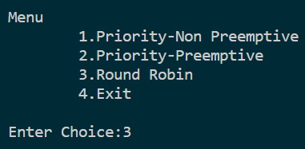

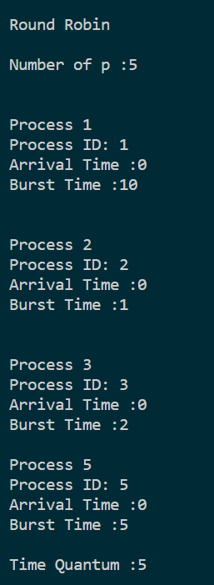

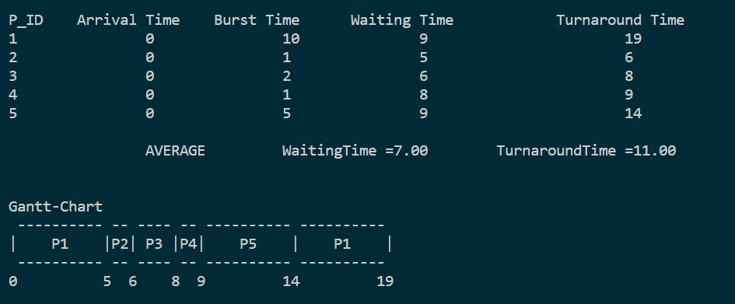

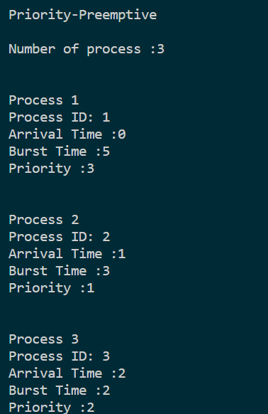

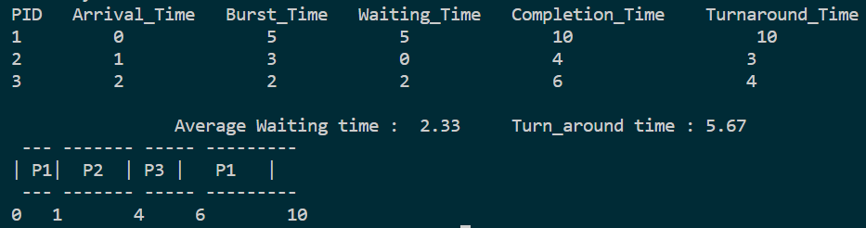

**Learning Outcome:**

* Implemented Pre-emptive Priority Scheduling and Round Robin Scheduling in C program
* Displayed Gantt Chart for the above scheduling methods